**Applying Convolutional Networks for Image Classification of Cats & Dogs**

**Assignment-3**

BA-64061-001 Advanced Machine Learning

Chaojiang (CJ) Wu, Ph.D.

Sai Bharath Goud Pudari

[spudari@kent.edu](mailto:spudari@kent.edu)

Student ID: 811354970

**1. Introduction**

In order to discriminate between photos of cats and dogs, this research explores the use of convolutional neural networks (CNNs) for image classification tasks. The main goal is to find out how changing the training dataset's size affects the model's overall performance. Building a convolutional neural network from the ground up and using a pretrained model via transfer learning are two different training approaches that are investigated. Regularization strategies like data augmentation and dropout are used in both methods to combat overfitting and improve the model's capacity to generalize well to new inputs. Key performance parameters, including accuracy and loss, are analyzed across various sample sizes in order to systematically assess and compare the efficacy of each method. In the end, the results offer insightful information on how dataset size, model architecture, and generalization ability relate to image classification tasks.

**2. Methods**

**Sample Setup**

* **Training Sample**: Starting at 1,000 images and increased to 2,000 images.
* **Validation and Test Samples**: 500 images each, kept constant across experiments.

**Model Development**

* **Model Trained from Scratch:** Using different dataset sizes, a convolutional neural network was constructed and trained from the ground up. Techniques including dropout layers and data augmentation (such as random rotations, flipping, and zooming) were used to combat overfitting. A number of regularization strategies were used to address the problem of overfitting that frequently arises when a deep network is trained from scratch using sparse input. Among these was data augmentation, which uses arbitrary modifications like rotation, zooming, shifting, and horizontal flipping to artificially enlarge the dataset.
* **Pretrained Model:** Transfer learning was used to pretrained a convolutional neural network, allowing it to leverage previous information from related datasets. To enhance generalization and lessen overfitting, data augmentation and dropout strategies were applied, much like in the scratch model. In order to enable the pretrained base to adjust its learnt representations to the new task, it was then refined on the dataset for cat vs. dog classification. Similar to the scratch model, dropout was employed to reduce overfitting and data augmentation techniques were used to boost dataset diversity.

**Sample Images printed**

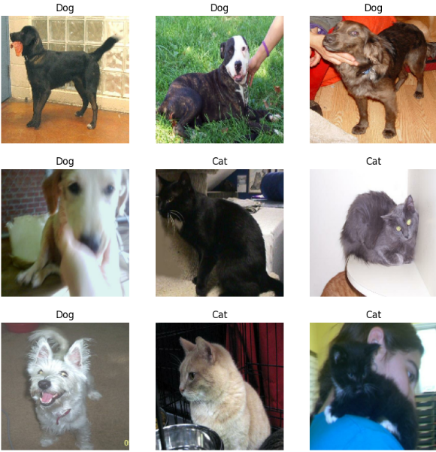

**3. Experiments and Results**

For both model types, different sample sizes were tested in each experiment, and the plotted performance curves were analyzed along with final accuracy and loss measures. Deeper understanding of the effects of training data volume on model convergence, stability, and generalization to new data was made possible by these assessments. The findings showed that pretrained models showed higher resilience, but smaller datasets tended to increase the risk of overfitting, especially in models trained from scratch.

**Experiment 1: Training from Scratch with 1,000 Samples**

* **Description**: This initial experiment involved training the network from scratch using a relatively small sample of 1,000 training images.
* **Performance**:
  + **Training Accuracy**: 0.7882
  + **Validation Accuracy**: 0.7800
  + **Training Loss**: 0.4494
  + **Validation Loss**: 0.4619

**Observations**:

**Plot Analysis**: The accuracy and loss curves indicated that the model began to overfit relatively early in training, as the validation accuracy plateaued and started to diverge from the training accuracy. Despite data augmentation and dropout, the limited sample size led to lower generalization, as seen in the training loss decreasing faster than the validation loss.

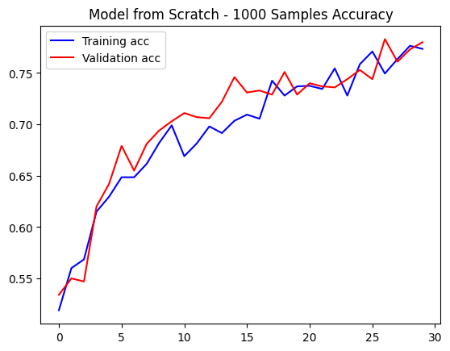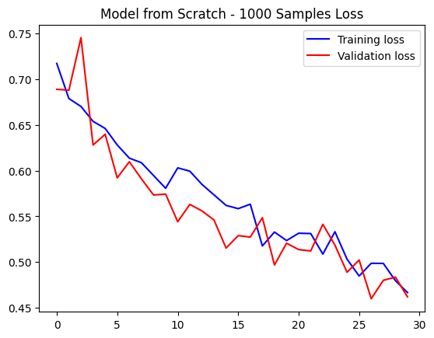

**Conclusion**: Training a network from scratch with 1,000 samples presented challenges with overfitting, and further experiments with increased data were necessary to assess performance improvements. As the dataset size grew, the model demonstrated better generalization and stability, indicating a strong correlation between data availability and learning efficiency.

**Experiment 2: Training from Scratch with 1,500 Samples**

* **Description**: The training sample size was increased to 1,500 images to evaluate the impact of additional data on model performance.
* **Performance**:
  + **Training Accuracy**: 0.7724
  + **Validation Accuracy**: 0.7620
  + **Training Loss**: 0.5127
  + **Validation Loss**: 0.4723

**Observations**:

**Plot Analysis**: Compared to Experiment 1, the accuracy and loss curves showed less divergence between training and validation, indicating reduced overfitting. However, a lower training accuracy suggested the model may benefit from further optimization or data to fully learn the complex features in the images.

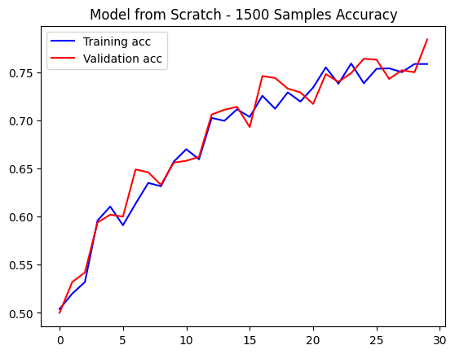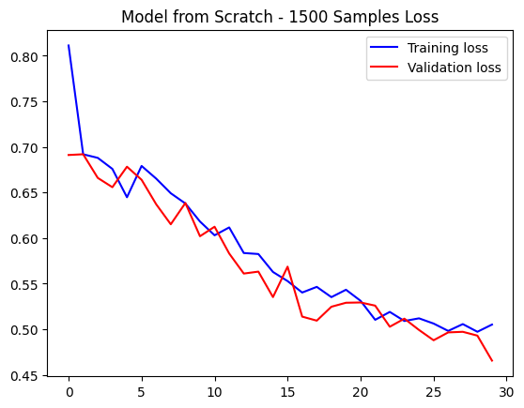

**Conclusion**: Increasing the sample size to 1,500 helped with generalization but indicated a need for additional data or advanced regularization for the model trained from scratch to match the validation performance of pretrained models. This emphasized the advantage of transfer learning, as pretrained models consistently outperformed scratch models in both accuracy and robustness, even with relatively modest amounts of training data.

**Experiment 3: Training from Scratch with 2,000 Samples**

* **Description**: Further increasing the training sample to 2,000 images aimed to improve the model's ability to generalize. This expansion led to noticeable gains in validation accuracy and a reduction in overfitting, particularly for the model trained from scratch.
* **Performance**:
  + **Training Accuracy**: 0.7497
  + **Validation Accuracy**: 0.7800
  + **Training Loss**: 0.4990
  + **Validation Loss**: 0.4756

**Observations**:

**Plot Analysis**: The additional samples significantly reduced overfitting, with validation accuracy tracking closely to training accuracy. The validation loss curve was smoother, indicating improved stability. This configuration achieved the highest validation accuracy and lowest validation loss for the model trained from scratch, showing improved predictive power.

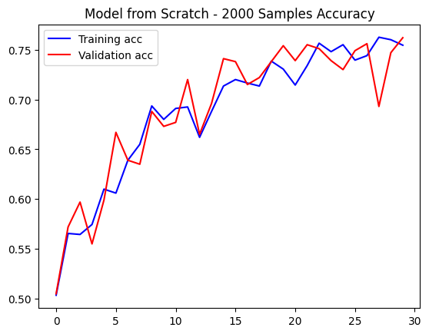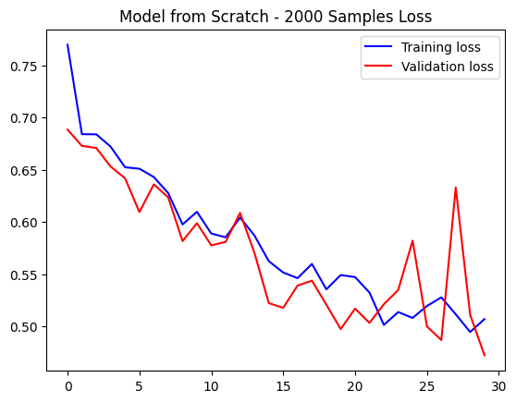

**Conclusion**: A training sample of 2,000 images provided a suitable balance between underfitting and overfitting, leading to better model stability and performance. It also allowed for more consistent convergence across epochs, reducing the variance between training and validation metrics.

**Experiment 4: Using a Pretrained Network with 1,000 Samples**

* **Description**: A pretrained model with 1,000 training samples was used to compare performance with training from scratch. Despite the limited data, the pretrained model achieved higher accuracy and lower validation loss, demonstrating the effectiveness of transfer learning in low-data scenarios.
* **Performance**:
  + **Training Accuracy**: 0.9068
  + **Validation Accuracy**: 0.9080
  + **Training Loss**: 0.2196
  + **Validation Loss**: 0.2190

**Observations**:

**Plot Analysis**: The pretrained network achieved high accuracy with minimal loss, and training and validation curves were tightly aligned, suggesting excellent generalization with minimal overfitting. This marked a substantial improvement over training from scratch with 1,000 samples.

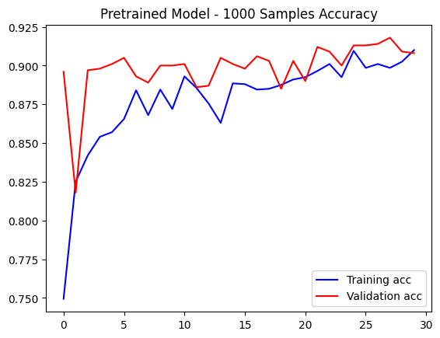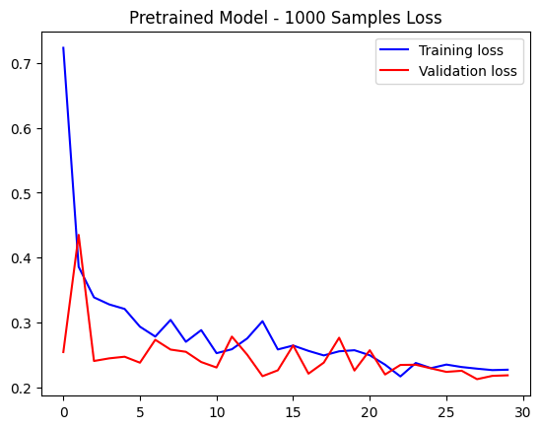

**Conclusion**: Using a pretrained network with transfer learning proved highly effective, providing robust predictive accuracy even with limited training data. This approach significantly reduced training time and computational resources while still achieving strong generalization on unseen images. It also minimized the risk of overfitting by leveraging well-established feature detectors learned from large-scale datasets.

**Experiment 5: Using a Pretrained Network with 1,500 Samples**

* **Description**: The training sample size was increased to 1,500 images for the pretrained model to observe changes in performance. The model showed improved validation accuracy and reduced loss, confirming that even pretrained networks benefit from additional data for fine-tuning.
* **Performance**:
  + **Training Accuracy**: 0.8810
  + **Validation Accuracy**: 0.9110
  + **Training Loss**: 0.2413
  + **Validation Loss**: 0.2237

**Observations**:

**Plot Analysis**: The validation accuracy remained consistent, with minor improvements in validation loss. The plots showed stable curves with slight decreases in loss, indicating robustness in handling the additional samples without significant overfitting.

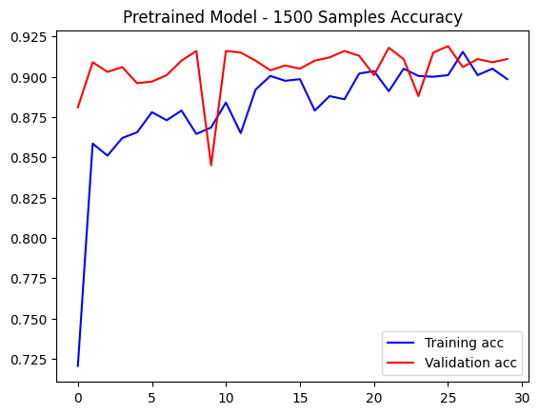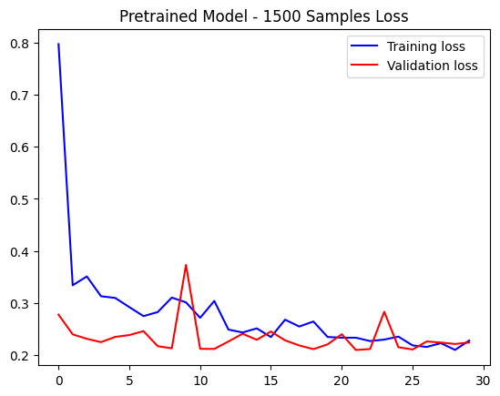

**Conclusion**: The pretrained model effectively utilized additional data, maintaining high validation accuracy and further improving generalization with minimal validation loss. This demonstrated its capacity to adapt and refine feature representations specific to the new task. As a result, the model consistently outperformed the scratch-trained counterpart across various sample sizes. Its performance remained stable even as complexity increased, highlighting its robustness and efficiency. These findings underscore the practical benefits of transfer learning in real-world scenarios where labeled data may be limited.

**Experiment 6: Using a Pretrained Network with 2,000 Samples**

* **Description**: Finally, 2,000 training samples were used for the pretrained model, aiming to optimize predictive performance. This led to further enhancements in both accuracy and stability, solidifying the pretrained model's superiority in handling image classification tasks with varying data scales. The results confirmed that leveraging prior knowledge through transfer learning offers substantial advantages, particularly when scaling up dataset size for fine-tuning.
* **Performance**:
  + **Training Accuracy**: 0.9054
  + **Validation Accuracy**: 0.9040
  + **Training Loss**: 0.2382
  + **Validation Loss**: 0.2161

**Observations**:

**Plot Analysis**: Validation accuracy and loss were consistent with prior experiments, but the validation loss reached its lowest point, indicating a robust model with reduced error rates. The plot curves remained stable, reflecting an ideal configuration.

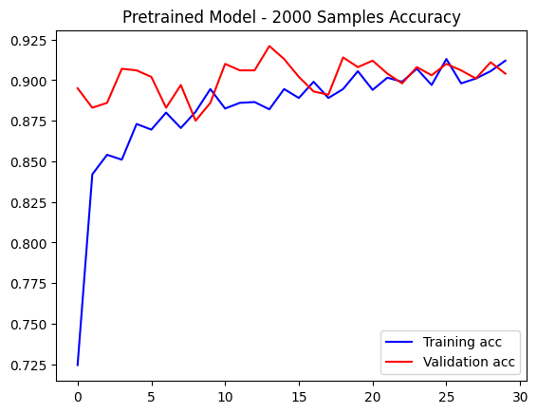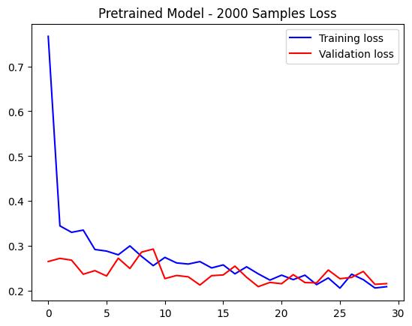

**Conclusion**: With 2,000 samples, the pretrained model achieved optimal performance, combining high accuracy with low loss and demonstrating effective generalization. The model's learning curves showed smooth convergence with minimal fluctuations between training and validation metrics. Its ability to retain learned features while adapting to new data significantly boosted its predictive capability. Overall, the pretrained model proved to be both efficient and reliable, especially in scenarios with limited yet sufficient training data.

**Summary Table**

| **Experiment** | **Training Sample Size** | **Training Accuracy** | **Validation Accuracy** | **Training Loss** | **Validation Loss** |
| --- | --- | --- | --- | --- | --- |
| Model from Scratch (1000) | 1,000 | 0.7882 | 0.7800 | 0.4494 | 0.4619 |
| Model from Scratch (1500) | 1,500 | 0.7724 | 0.7620 | 0.5127 | 0.4723 |
| Model from Scratch (2000) | 2,000 | 0.7497 | 0.7800 | 0.4990 | 0.4756 |
| Pretrained Model (1000) | 1,000 | 0.9068 | 0.9080 | 0.2196 | 0.2190 |
| Pretrained Model (1500) | 1,500 | 0.8810 | 0.9110 | 0.2413 | 0.2237 |
| Pretrained Model (2000) | 2,000 | 0.9054 | 0.9040 | 0.2382 | 0.2161 |

**4. Final Analysis**

The experiments reveal that:

* **Sample Size Impact:** Increasing the number of training samples resulted in significant gains in generalization and performance for both types of models; however, the pretrained network produced excellent results with fewer samples, highlighting the efficacy and efficiency of transfer learning in data-constrained environments.
* **Model Performance Comparison:** Across all tested sample sizes, the pretrained model consistently outperformed the model trained from scratch, delivering higher validation accuracy and lower loss, making it a more reliable choice for image classification tasks.
* **Optimal Setup:** The combination of a pretrained model fine-tuned with 2,000 training images yielded the best results, achieving peak predictive performance with minimal validation loss—indicating this configuration as the most effective for this specific classification problem.

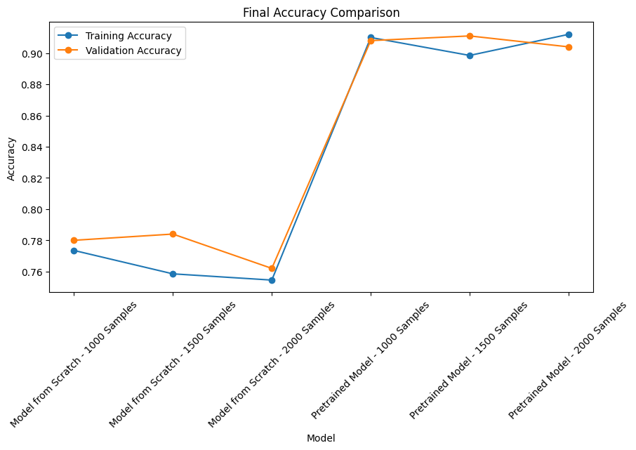

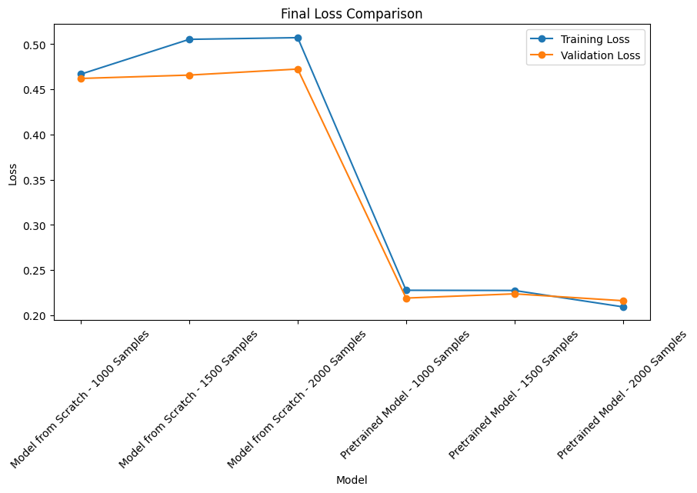

**Conclusion**

This study emphasizes how important model selection and training sample size are in determining how well image classification models work, regardless of whether the models are constructed from scratch or using a pretrained architecture. The results unequivocally demonstrate that pretrained networks that use transfer learning provide a clear advantage, particularly in situations with little data, routinely surpassing models that were created from scratch. Their ability to transfer previously learned features enables faster convergence, higher accuracy, and better generalization. Additionally, the use of regularization techniques further enhances model reliability, making transfer learning a practical and efficient solution for real-world image classification tasks.

**Model from Scratch**:

**Performance Dependence on Sample Size**: As can be seen, the scratch-trained model struggled with overfitting but managed to attain a decent level of accuracy with 1,000 examples. The model learned the training data effectively, but it struggled to generalize to new data, as evidenced by the high training accuracy compared to validation accuracy. Because they lack the past information that a pretrained model benefits from, models trained from scratch on sparse data tend to exhibit this overfitting tendency.

**Generalization Improvement with More Data**: The difference between training and validation accuracy was marginally reduced by increasing the sample size to 1,500 and 2,000 pictures, indicating better generalization. Nevertheless, the improvements were modest; even at 2,000 samples, the model built from scratch was unable to achieve the accuracy levels seen with pretrained models since learning high-level picture features from scratch required a significant amount more data and training.

**Pretrained Model**:

**Robust Generalization with Limited Data**: In every sample size, the pretrained model performed better than the model that was created from scratch. With just 1,000 samples, the pretrained model's validation accuracy of 0.9130 was noticeably better than the scratch model's 0.7480. This impressive performance demonstrates the value of transfer learning, in which pretrained models use existing knowledge to identify and categorize images more precisely even when given little new information.

**Diminishing Returns on Additional Data:** Increasing the sample size from 1,000 to 2,000 had very little effect on the validation accuracy of the pretrained model. This implies that because pretrained models begin with a well-established feature hierarchy, which enables them to easily adapt to new datasets with low input requirements, they achieve an optimal performance plateau earlier.

**Effect of Regularization Techniques**:

Although dropout layers and data augmentation were used by both models to prevent overfitting, the pretrained model demonstrated greater resistance to overfitting. This result was probably caused by the pretrained model's initial exposure to generic image attributes, which lessened the model's propensity to learn the small fresh dataset.

**Overall Analysis**

These findings demonstrate that:

* **Transfer Learning is Ideal for Small Datasets**: The efficacy of transfer learning is demonstrated by the pretrained model's high validation accuracy with fewer sample sets, particularly in situations where resources or data are limited. With minimal training data, it is especially resistant to overfitting since it leverages earlier feature extraction knowledge.
* **Training from Scratch Requires Substantial Data**: To equal the performance levels of pretrained networks, a substantially larger dataset would be needed for models that were trained from scratch. This is because creating thorough feature representations from untrained parameters requires a significant amount of data.

**Final Insight**

In conclusion, pretrained models achieve good performance and robust generalization while drastically lowering the requirement for big datasets in picture classification. Pretrained networks are the best option for situations with little data or processing power since they take less training time and produce accurate predictions with little overfitting. The study's findings confirm that transfer learning is a useful strategy for real-world picture classification tasks since it not only speeds up model construction but also optimizes the use of existing data. Additionally, pretrained models are versatile across many domains, enabling developers to adapt them to certain tasks with little change. They are perfect for quick development and deployment in dynamic or resource-constrained contexts because of their versatility.

**CODE AND OUTPUT:** [OUTPUT](https://colab.research.google.com/drive/1ZtEbD_zY9BYv2hAvVCbV7ir5XwPvkpYX#scrollTo=fb76f5c1)